MENTOR - MENTEE LOG BOOK

Student Details
Name: Noorain Eqbal |  | Registration No.: 230953454
Section: C | Roll No.: 50 | Branch: CCE
Mobile No.: 9608145716 |  | E-mail Id: nooraineqbal@gmail.com
Hostel Block No.: 8 | Room No.: 324 | Blood Group: A+ | Date of Birth: 13/12/2003
  Any MIT/MU alumni in your family? Yes  / No |  | - If Yes, please give their names, branch, batch, institution and relationship
Details of the Parents
Father’s Name: Jawed Eqbal |  | Mother’s Name: Sanober Tahseen Waris
Occupation: Property Valuer      Entrepreneur: Family business:  Public Sector: Professional: Govt. Employee: Pvt. Company: |  |   Occupation: Teacher  Home Maker: Entrepreneur:  Family business: Public Sector:  Professional: Govt. Employee : Pvt. Company:
Name of the organization and designation: |  | Name of the organization and designation: Loreto Convent School, Ranchi
Mobile No.:9608342117 |  | Mobile No.: 8797781572
E-mail Id: jawedeqbal100@gmail.com |  | E-mail Id: sanoberwaris@gmail.com
Address for Communication:  S/O Jawed Eqbal, Azad Basti, Mission Ground, Ranchi  Pin Code: 834001 |  | Permanent Address:  S/O Jawed Eqbal, Azad Basti, Mission Ground, Ranchi  Pin Code: 834001
Business Card of the Parent  Business Card |  | Signature of the Student  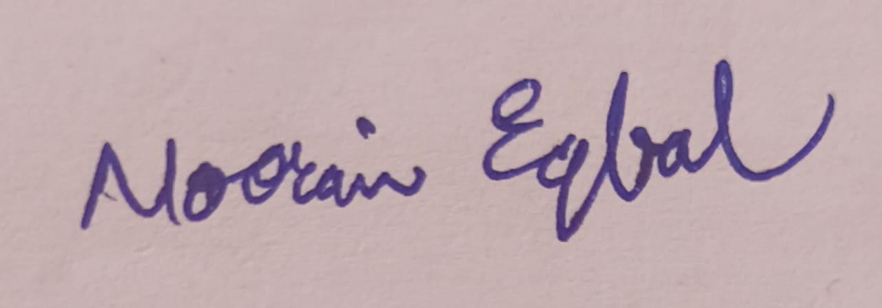  photo

Mentor Details
Name:
Designation:
Phone Number:
Mail ID:
LinkedIn:
Signature of the Mentor:

ACADEMIC RECORD

 | Semester 1 – Semester End Exam Result |  |  |  |  | Remarks
Code | Course | Credits | Internal Marks (Max: 50) |  | Grade
GPA: |  |  |  | CGPA:
RECORD OF MENTOR MENTEE MEETING

Date and Time | Discussion | Signature of the student
 | Discussion on academic and personal progression.

 | Semester 2 – Semester End Exam Result |  |  |  |  | Remarks
Code | Course | Credits | Internal Marks (Max: 50) |  | Grade
GPA: |  |  |  | CGPA:
RECORD OF MENTOR MENTEE MEETING

Date and Time | Discussion | Signature of the student

 | Semester 3 – Semester End Exam Result |  |  |  |  | Remarks
Code | Course | Credits | Internal Marks (Max: 50) |  | Grade
GPA: |  |  |  | CGPA:

RECORD OF MENTOR MENTEE MEETING

Date and Time | Discussion | Signature of the student

 | Semester 4 – Semester End Exam Result |  |  |  |  | Remarks
Code | Course | Credits | Internal Marks (Max: 50) |  | Grade
GPA: |  |  |  | CGPA:
RECORD OF MENTOR MENTEE MEETING

Date and Time | Discussion | Signature of the student

 | Semester 5 – Semester End Exam Result |  |  |  |  | Remarks
Code | Course | Credits | Internal Marks (Max: 50) |  | Grade
GPA: |  |  |  | CGPA:

RECORD OF MENTOR MENTEE MEETING

Date and Time | Discussion | Signature of the student

 | Semester 6 – Semester End Exam Result |  |  |  |  | Remarks
Code | Course | Credits | Internal Marks (Max: 50) |  | Grade
GPA: |  |  |  | CGPA:
RECORD OF MENTOR MENTEE MEETING

Date and Time | Discussion | Signature of the student

 | Semester 7 – Semester End Exam Result |  |  |  |  | Remarks
Code | Course | Credits | Internal Marks (Max: 50) |  | Grade
GPA: |  |  |  | CGPA:
RECORD OF MENTOR MENTEE MEETING

Date and Time | Discussion | Signature of the student

 | Semester 8 – Semester End Exam Result |  |  |  |  | Remarks
Code | Course | Credits | Internal Marks (Max: 50) |  | Grade
GPA: |  |  |  | CGPA:
RECORD OF MENTOR MENTEE MEETING

Date and Time | Discussion | Signature of the student

EXTRA CURRICULAR ACTIVITY

Date | Activity | Signature of the student

